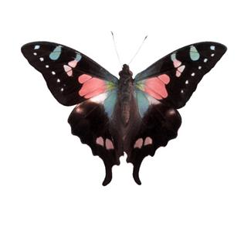
The Butterfly Effect

Objective:
- Students will research one major event in history and alter its outcome.
- Students will create a unique timeline that documents facts and also explores unique possibilities.

Goals:
- Students will comprehend cause and effect and be able to demonstrate their understanding of this.
- Students will research and document significant historical facts from their chosen event.
- Students will design an alternative reality mirroring actual events.

Requirements:
- After some extensive research, students will pick one major historical event and alter the outcome.
- Events may not be doubled so students must post their event on Edmodo. First post wins the event.
- A title is needed – Large and colorful.
- Students will pose the question, “What if…?”
  - Examples:
    - What if the South had won the Civil War?
    - What if JFK had not been assassinated?
- Before students receive their timeline paper, a rough draft of their timeline must be shown to Mrs. Strenge (see attached paper).
- Students will make one timeline with pictures and captions outlining the outcomes of both events.
- The timeline will go from the moment of the actual event until present day – 2013 – documenting significant events.
  - Events can include government, politics, economy, religion, technology, social reform, health, beauty, entertainment, etc.
  - If you have an idea that is not mentioned, please see me.
    - 20+ Events & 10 pictures = A
    - 15-19 Events & 8 pictures = B
    - 10-14 Events – 6 pictures = C
- Pictures on the timeline may be drawn or traced. Part of the grade is based on originality, color, and neatness.
- The timeline must be school appropriate. Any concerns should be directed to Mrs. Strenge BEFORE the project is turned in for a grade.
- The timeline must be unique and artwork must be drawn or traced.
- The timeline must be colorful and visually appealing.
- The information on the timeline will be printed (yes, printed)
- The timeline will be displayed.

Due Date:
- The assignment is due on Friday, December 19th.

