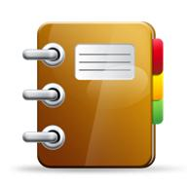
Binder Order
1st Tab AR
2nd Tab Vocabulary
3rd Tab Grammar
4th Tab Writing
5th Tab Literature
6th Tab Media/Speech

