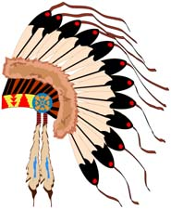
Creation Myth

Objective – Create a pictorial design and typed summary of a Native
American myth.

Requirements:
- Eight pictures in blocks explaining the creation myth
  - Creative border (tribal colors and patterns recommended)
  - Images must be neat and detailed
  - Vivid colors and graphics
  - Tracing is allowed & encouraged
  - No words allowed
  - Hint – create a rough draft first
- A one-page summary of the myth
  - Paraphrased (plagiarism results in a zero)
  - Written at 9th Grade Level
  - Saved on Google Docs (shared with me)
  - Typed
  - Double-spaced
  - Size 12
  - Comic Sans font
  - Title of the myth
- All materials must be school appropriate
- Both pages will be laminated (don’t bend papers)

Deadline:
- Monday, February 13th (beginning of class)

