FINDING NEMO

In this underwater adventure, with memorable characters, humor and heartfelt emotion, Finding Nemo follows the comedic and momentous journey of an overly protective clownfish named Marlin and his son Nemo who become separated in the Great Barrier Reef when Nemo is unexpectedly taken far from his ocean home and dumped into a fish tank in a dentist's office. Buoyed by the companionship of Dory, a friendly-but-forgetful Pacific regal blue tang, Marlin embarks on a dangerous trek and finds himself the unlikely hero of an epic effort to rescue his son -- who hatches a few daring plans of his own to return safely home.

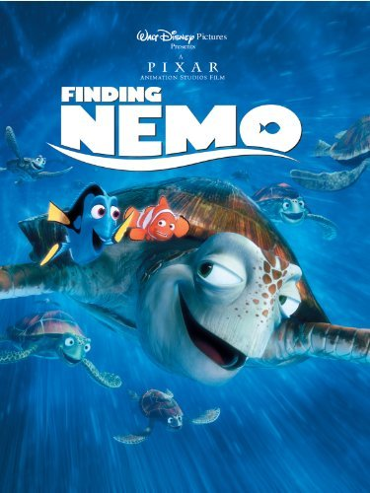

TAKEN NEMO

A picture perfect family that is soon destroyed when everyone but his son Nemo is viciously devoured by a barracuda. Determined to keep his only offspring safe, Nemo rebels against his father’s rules and is soon abducted by scuba divers who force him into performing aquatic shows for a sociopathic human child. Marlin will stop at nothing to get back his son. If it’s money they want, he has none; but he does have a particular set of gills, which sets him apart from the rest of the fish population, and he isn’t afraid to use them. He’s out for vengeance and will use any means necessary to rescue his son, even if it means faking friendships, intimidating others, and hiring muscle to do his dirty work.

