IDEAS

Purpose: Making sure ideas are small and focused; showing, not telling.

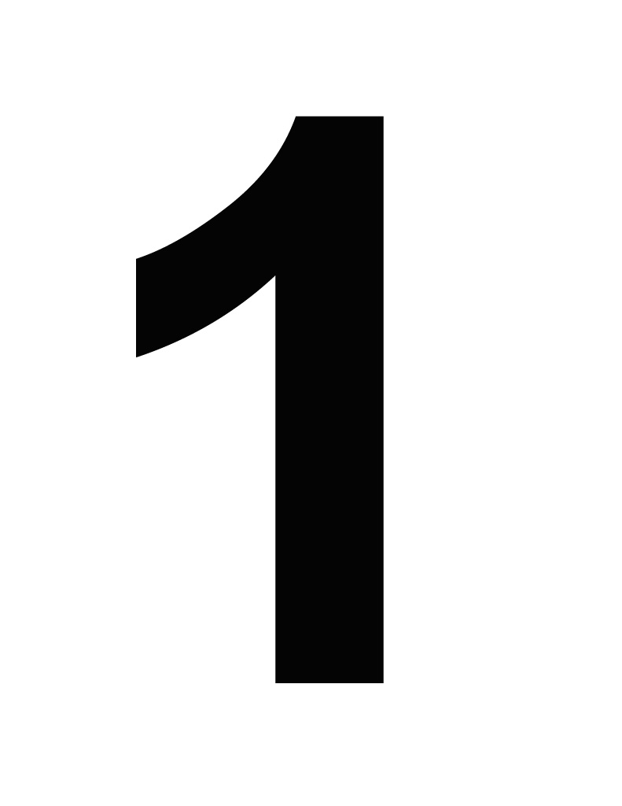
NOVICE:
- I put my first thoughts on paper.
- You couldn’t call it an essay or story – yet.
- I am still figuring out my topic.

EMERGING:
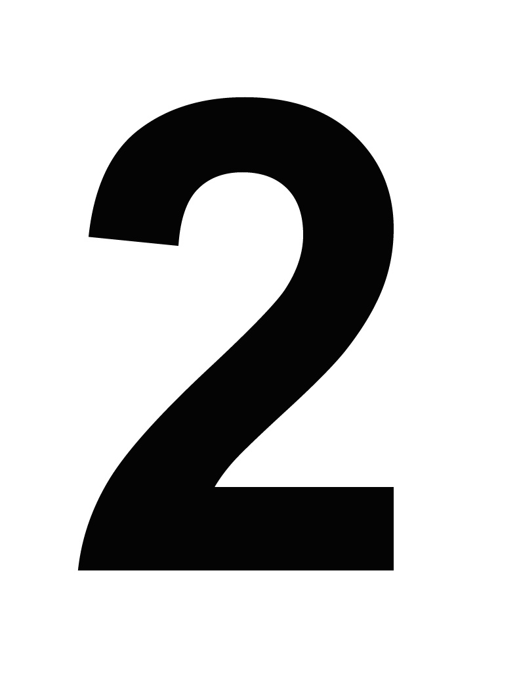
- A reader might have trouble figuring out the main message.
- The story or message isn’t really clear in my mind.
- I just wrote to fill the page.
- I repeat things – or stop when I run out of things to say.
- I bounce from topic to topic – or list thoughts at random.

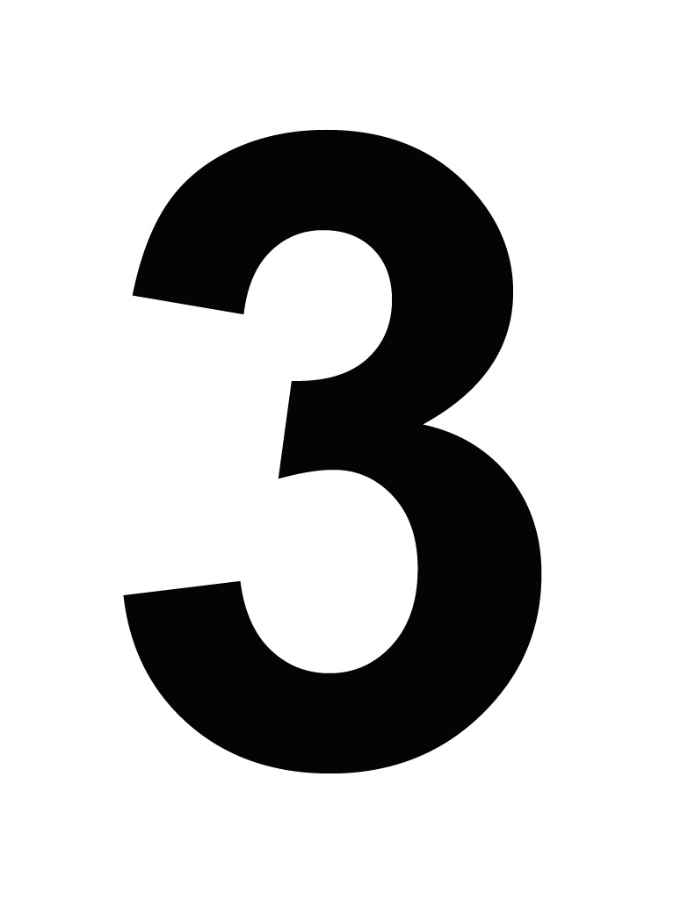
DEVELOPING:
- A reader can guess what my main idea is – or tell what my story is about.
- I know enough to start – then I have to make things up.
- My details are general – things many readers already know.
- My topic feels way too BIG. I can’t cover everything.

PROFICIENT:
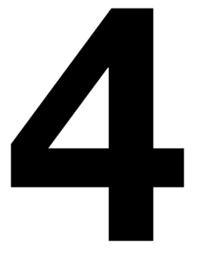
- A reader can identify my main idea or make sense of my story.
- I have enough information for a first draft but more would help.
- My writing includes a few interesting details. Readers might want more.
- I think I need to narrow my topic a little. I’m trying to cover too much.

STRONG
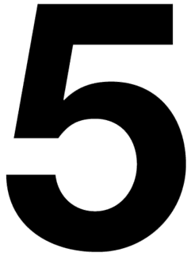
- My main message or story is interesting and easy to understand.
- I share important information – and tell enough to give readers a full picture.
- My paper contains many interesting (not random) ideas.
- I narrowed my topic to give readers an in-depth look at my subject.

EXEMPLARY:
- My main message or story is clear and will hold your attention.
- I know this topic inside and out and take readers on a journey of discovery.
- I included intriguing details a reader will notice and remember.
- My writing makes a point – or focuses on a clearly defined message or issue.

ORGANIZATION

Purpose: Putting things in order that make sense; using a strong lead and conclusion;
connecting ideas with transitions.

NOVICE:
- This is just a bunch of ideas tossed together.
- NOTHING goes with anything else. Don’t look for a pattern!
- It’s just random thoughts on a page.
- I don’t know how to begin.
- I don’t know how or when to stop, either.

EMERGING:
- This is HARD to follow. I jumped from topic to topic.
- Reorganization is NEEDED! Where is this going? This is like a messy closet!
- There is no main idea.
- Where is the opening? I need a new lead.
- The ending just stops! I need a new conclusion, too!

DEVELOPING:
- The information is not always in order – confusing!
- Here and there – it’s hard to follow.
- The opening isn’t exciting.
- There is no summary for the ending.

PROFICIENT:
- MOST things are in the right spot.
- I could move some things around.
- My opening and ending are OKAY.
- It gets your attention and the paper doesn’t just stop.

STRONG
- You will NOT feel lost.
- Things are in order.
- The main ideas stand out.
- My opening and ending are clear and catchy.

EXEMPLARY:
- This is like following a road map!
- Every detail is JUST in the right place.
- My main ideas stand out.
- The introduction and conclusion are AWESOME!

WORD CHOICE

Purpose: Painting word pictures; finding the right words for the message; using strong
verbs, colorful nouns, and vivid descriptions.

NOVICE:
- This doesn’t make much sense.
- The words don’t seem to work. My writing doesn’t help you picture things.
- I need to express things differently to make the paper clear.
- I wasn’t sure how to use verbs correctly.

EMERGING:
- My words are sometimes CONFUSING – I don’t know what some mean.
- I think a lot of my words are ordinary – everyone uses them.
- Most of my verbs are is, are, was, and were. There is no real action!
- I told about things you see, but there are no words describing sounds, smells, feelings, or tastes.
- It’s too wordy – or else I didn’t say enough.

DEVELOPING:
- Not all words are used correctly.
- I had 1-2 good moments, though.
- Most of my verbs are not lively or strong.
- I didn’t try to be original – I used whatever came first to my mind.

PROFICIENT:
- My words are CLEAR, and most are used correctly.
- I repeated a few things.
- Some verbs are strong, but some are ordinary (is, are, was, and were).
- I didn’t always try to say things in a new way.
- Sometimes I repeated things or used words I didn’t need.
STRONG
- My words are all used CORRECTLY.
- Many of them paint pictures in your mind.
- Most verbs are strong.
- I found some new things to say.
- I used sensory details in the right spots. There is little to no clutter.

EXEMPLARY:
- Every word I choose helps make my meaning clear.
- I LOVE the words in this essay or story.
- The verbs are strong and lively!
- I have word choice that is different from other papers you have read.
- Sensory details put readers right at the scene.
- You won’t find clutter. Every word counts!
SENTENCE FLUENCY

Purpose: Making it readable and smooth; giving sentences variety in length and structure;
reading it aloud flawlessly.

NOVICE:
- These “sentences” don’t make sense to me.
- I can’t read this aloud with fluency.
- I have to fill in missing words or hook words together to make real sentences.

EMERGING:
- This is HARD to read aloud.
- Sometimes I went on and on and on with one HUGE sentence instead of two.
- Other parts sound as CHOPPY as a grocery list.
- I use the same sentence patterns over and over.
- I might have some FRAGMENTS.
- I didn’t use dialogue, or else I couldn’t make it sound real.

DEVELOPING:
- To read this aloud, you’d need PRACTICE. It doesn’t sound natural.
- Most of the sentences begin the same way and are the same length – BORING.
- There is no variety.
- If I used dialogue, it needs work.

PROFICIENT:
- My writing is easy to read with a little practice
- There’s enough variety to make sentences interesting. Some are longer or shorter than others. Some sentences begin in different ways.
- With a little effort, you can make this writing sound fairly fluent.
- If I used dialogue, it’s pretty realistic.

STRONG
- My paper is EASY to read aloud. There are no bumps or sudden stops.
- MANY sentences begin in DIFFERENT ways, and they differ in length and structure.
- I used both short and long sentences.
- If I used dialogue, it sounds like a real conversation.

EXEMPLARY:
- My writing is smooth and easy to read on the first try.
- Sentences differ in length and begin in ways that show how ideas connect.
- Almost every sentence begins differently.
- You can read this expressively to bring out every ounce of voice
- If I used dialogue, it’s so real that you can perform it like a play.

VOICE

Purpose: Putting yourself into your writing; reaching out to the audience; making sure the
voice is right for the purpose and topic.

NOVICE:
- I don’t hear ANY voice in this writing.
- I didn’t like this topic so I DID’T TRY. It sounds like I wasn’t interested in writing this.
- There is nothing in this writing to make it mine. I wrote what I had to write to finish the assignment.

EMERGING:
- This sounds like an ENCYCLOPEDIA, not me. There is no personality to this writing.
- I don’t feel ready to share this writing – yet.
- I need a topic I know and care more about.
- I’m still figuring out my purpose and who my readers are.

DEVELOPING:
- It might sound a LITTLE like me.
- With some work, parts would be ready to share.
- I tried to sound excited – I couldn’t do it all the time.
- This voice won’t reach all readers.
- This was an okay topic, but I’m not sure who my audience is or if I care.

PROFICIENT:
- My writing is easy to read with a little practice.
- There’s enough variety to make sentences interesting. Some are longer or shorter than others. Some sentences begin in different ways.
- With a little effort, you can make this writing sound fairly fluent.
- If I used dialogue, it’s pretty realistic.

STRONG
- My voice is CLEAR, and I think it sounds like me.
- It’s FUN to read aloud and share with others.
- I LIKE this topic –so I worked hard to make it INTERESTING for my reader.
- This voice fits my purpose – and will get readers involved.

EXEMPLARY:
- This is ME! You can hear my voice in every line.
- A reader would love sharing this aloud.
- This topic matters deeply to me, and I said exactly what I felt and thought.
- I’m writing for YOU, the reader.

CONVENTIONS

Purpose: Editing; proofreading; looking over the layout to see how the information is
presented.

NOVICE:
- I have SO many mistakes that I can hardly read this! I need to go over this word-by-word.
- I need a LOT of help with my editing.
- Layout – does it really matter how it looks?!

EMERGING:
- I NEVER edited! I need to proof it line-by-line by reading it aloud.
- My mistakes make it HARD to read.
- I’m not sure how to make it look good on the page.
- Readers will need to “edit” as they read – that should have been my job!
- I didn’t think about presentation yet.

DEVELOPING:
- I have made quite a few mistakes, but I did do a little editing.
- Readers will notice my MISTAKES more than the message!
- Mistakes could puzzle readers or force them to read some things twice.
- I need to work on presentation. Readers can’t tell what to focus on.
- I don’t think this looks as good as it should.

PROFICIENT:
- Errors are noticeable, but they won’t slow readers down.
- I need to go over this one more time, reading it aloud as I edit.
- I made some mistakes, and my spelling, punctuation, and grammar are OKAY.
- My conventions support the message and make reading fairly easy.
- My presentation is OKAY – it draws attention to key points.

STRONG
- I made a few minor errors – but nothing serious.
- It might need a few touchups, but it’s almost ready to publish.
- My conventions support meaning and voice.
- My spelling, punctuation, and grammar are GOOD.
- My paper looks sharp.

EXEMPLARY:
- You have to be really PICKY to find mistakes.
- I edited it and looked REALLY HARD for mistakes. I edited carefully, reading silently and aloud. This is ready to publish.
- The spelling, punctuation, and grammar are EXCELLENT!
- My presentation has eye appeal and makes information easy to find.

