Scholarly Article in an Online Database - General MLA 5.6.4
Cite the article as you would a print source, followed by:
- Name of the database (italicized)
- Medium of publication (Web)
- Date of Access
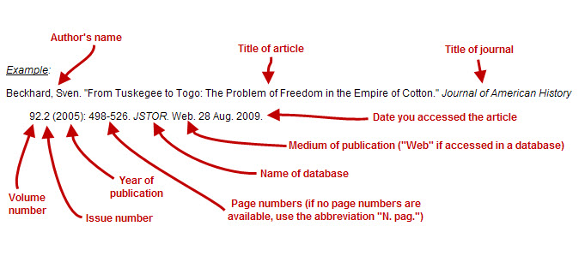

Newspaper Article in an Online Database - General MLA 5.6.4
Cite the article as you would a print source, followed by:
- Name of the database (italicized)
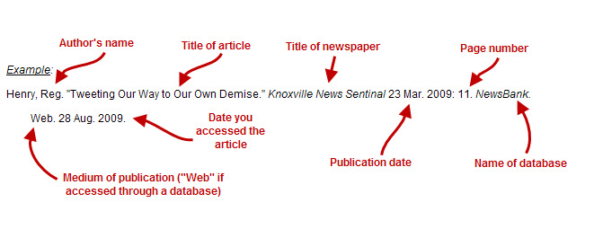
- Medium of publication (Web)
- Date of Access

Magazine Article in an Online Database - General
Cite the article as you would a print source, followed by:
- Name of the database (italicized)
- Medium of publication (Web)
- Date of Access
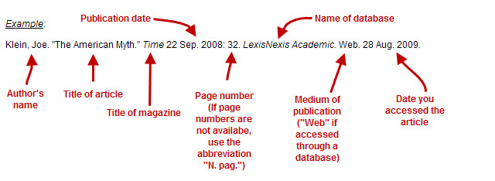

eBook in an Online Database - General MLA 5.6.4
Cite the article as you would a print source, followed by:
- Name of the database (italicized)
- Medium of publication (Web)
- Date of Access
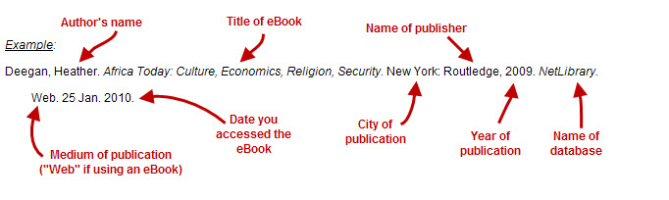

Television Broadcasts in a Database MLA 5.6.2b
Essential Elements:
- Name of the author, compiler, director, editor, narrator, performer, or translator of the work, if available
- Title of the episode or segment, if appropriate (in quotation marks)
- Title of the program or series (italicized)
- Title of the overall Web site, if different from title of program/series (italicized)
- Publisher/sponsor of the site, as appropriate (if not available use N.p.)
- Database name, as appropriate (italicized)
- Date of publication (day, month, and year; if not available use n.d.)
- Medium of publication (Web)
- Date of access (day, month, and year)

Example:
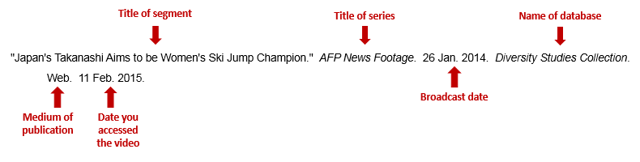
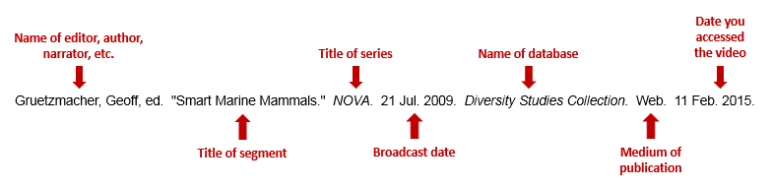

Interviews on TV or Radio MLA 5.7.7
Essential Elements:
- Name of interviewee
- Name of interviewer, as appropriate
- Title of episode or segment, as appropriate (in quotation marks)
- Title of program or series, as appropriate (italicized)
- Name of the network, if any
- Call letters and city of the local station, if any
- Broadcast date
- Medium of reception (e.g., Radio, Television)
- Title of Database (italicized)
- Medium of publication (Web)
- Date of access

Example
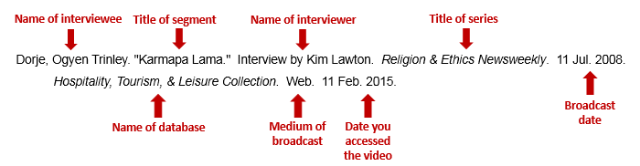
*See Multimedia for more information

Examples from Library Databases

Academic OneFile
Scholarly Journal:
Phillips, Gervase. “Warhorses of the U.S. Civil War.” History Today 55.12 (2005): 10-17. Academic OneFile. Web. 28 Aug. 2009.

Newspaper:
Filfield, Anna. "Battle Not Yet Won Over US Healthcare Reform." Financial Times 23 Dec. 2009: 4. Academic OneFile. Web. 13 Jan. 2010.

Magazine:
Pickert, Kate, and Karen Tumulty. "What Health Care Reform Means for the States." Time 18 Jan 2010: 44. Academic OneFile. Web. 13 Jan. 2010.

eBook:
Borza, Eugene N. "Alexander the Great." The Reader's Companion to Military History. Boston: Houghton, 1996. N. pag.
Academic OneFile. Web. 22 Jan. 2010.

United States Congressional Documents

Bills and Acts
The issuing agency is always either the House or the Senate.

U.S. [Senate/House]. [nth] Congress, [nth] Session. [Bill number], Bill title, may be shortened. Edition statement.
Washington: Government Printing Office, year.

Cited example
U.S. House. 75th Congress, 1st Session. H.R. 6786, A Bill to Protect Purchasers of Hats. Washington, Government
Printing Office, 1937.

Committee Prints
Committee prints are the working papers and reports of committees. The Senate has an official numbering system for them (since 1983), but the House does not.

Cited item
U.S. Senate. Committee on Rules and Administration. Expenditure Authorizations and Requirements for Senate
Committees (S.Prt. 112-2). Washington: Government Printing Office, 2011. (Y4.R86/2:S.PRT.112-2).

Cited item
U.S. House. Committee on Interior and Insular Affairs. National Trails System Act Amendments of 1980. Washington:
Government Printing Office, 1980. (Y4.In8/14:T68).

Cited item
U.S. Congress. Committees on Foreign Relations of the U.S. Senate and the International Relations of the U.S. House of
Representative. Annual Report on International Religious Freedom: 2000. Washington: Government Printing Office,
2000.

Hearings
After the title, put "Hearing, [date of hearing]."

Cited item
U.S. House. Committee of Ways and Means. Child Care and Child Welfare Hearing, 3 February 1995. Washington:
Government Printing Office, 1995. (Y4.W36:104-14)

Reports, Documents, Executive Reports, Executive Documents
These are official, numbered documents issued by the House or Senate. Use these abbreviations to cite them as shown in the example.

House Document = H.Doc.
Senate Document = S.Doc.
House Report = H.Rpt.
Senate Report = S.Rpt.

Cited item
U.S. Senate. Committee on Energy and Natural Resources. Franklin D. Roosevelt Family Lands: Report Together with
Minority Views (to accompany S. 134) (S.Rpt.104-32). Washington: Government Printing Office, 1995.

Serial Set
If the version of the document you are using came from the serial set, include the serial set volume in the note.

Cited item
U.S. Senate. 50th Congress, 2nd Session. Report on Indian Traderships (S.Rpt.2707). Washington: Government Printing
Office, 1899. (Serial Set 2623).

