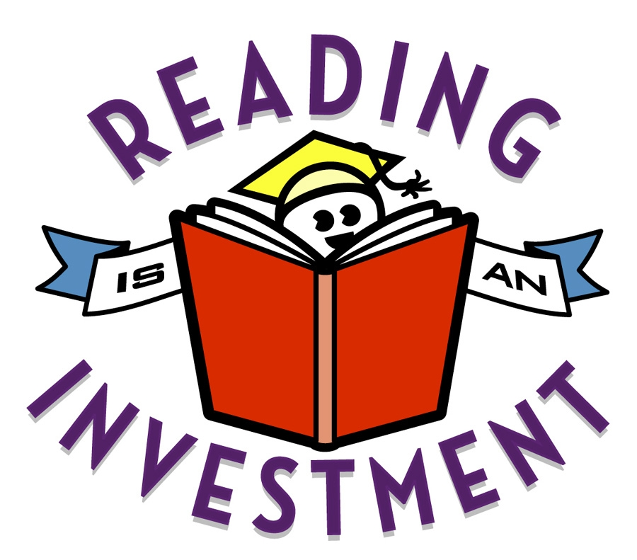
Name______________________
Class_________ Date________
Notice and Note
Directions: Be sure to follow the example given with this handout; it is also posted on my website. Complete sentences are required. Only use pronouns after you have explained to whom you are referring. The assignment must be typed using Chalkboard font size 12. Once you earn 100% on your next AR test, you will not be assigned Notice & Note UNLESS you failed to correctly follow the directions.

Book Title: Author:
Contrasts & Contradictions | What character’s action or feeling was unexpected? | Pg. # | What was unexpected about  that action/feeling? | Why do you think the character acted/felt that way?
1. (Copy word-for-word)

2. (Copy word-for-word)

Aha Moment | What words told you this was going to  be an Aha Moment? | Pg. # | What realization came to the  character’s mind? | How is this realization likely to be important in the story?
3. (Copy word-for-word)

4. (Copy word-for-word)

Tough Questions | How did you know this was going to be  a Tough Question? | Pg. # | What did you wonder about  when you thought about this  question? | How is this realization likely to be important in the story?
5. (Copy word-for-word)

6. (Copy word-for-word)

Words of the Wiser | What did you see that told you this was going to be a Words-of-the-Wiser moment? | Pg. # | What advice or insight did the wiser character share? | How do you think this will affect the main character (or the one who received the advice)?
7. (Copy word-for-word)

8. (Copy word-for-word)

Again and Again | What did you find that keeps coming up over and over again. | Pgs. # | Why do you think the author keeps repeating this word, phrase, image, idea, or situation? | What does this Again and Again signpost lead you to think is going to happen later in the story?
9. (Copy word-for-word)

10. (Copy word-for-word)

Memory Moment | What was happening when the character recalled the memory? | Pg. # | What memory came to the character’s mind? | Why do you think this memory is important to the character or to the story?
11. (Copy word-for-word)

12. (Copy word-for-word)

