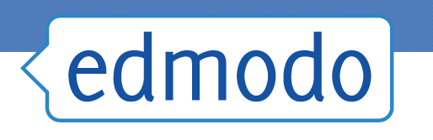
Parent Sign Up (Web)
After your child has created a Student Account, you can create a Parent Account using your child's unique Parent Code. You will not use a Group Code as Parent Accounts do not join Groups. Once you create your Parent Account, you are automatically observing any Group/class that your child is part of on his/her account.

You will need an email address to sign up for your Parent account. If your email addresses is in use on your child's Student account, then you can remove the email address from the student account so that you can use it on your Parent account. Student accounts do not require an email address.

How to Sign Up as a Parent:
- Obtain the unique 6-digit Parent Code from your child’s account (this is not the same as your child’s Group Code/s).
- The Parent Code is attached to your child’s account. Each child has a different Parent Code. You can find your Parent Code the following way:
  - Your child’s Edmodo Homepage: the Parent Code is located on the bottom of the left side panel.
- Go to www.edmodo.com on a web browser
- Click “Parents.”
- Fill in the necessary information and your unique Parent Code, and check the box to agree to the Terms of Service and Privacy Policy.
- Click "Sign Up."

You only need one Parent Account your entire time on Edmodo. Even if you have multiple children using Edmodo, you can add them all to your one account. There is never a need to create a new Parent Account (and there is never a need for your child to create a new Student Account as well). If your child did create a new account, simply obtain the Parent Code associated with your child's new account and add it to your existing Parent Account. As your child joins or leaves classes or schools, your account will automatically update to reflect these changes.

Note: Each child has a different Parent Code. You do not have to share a Parent Account with another parent, relative, or guardian. Multiple Parent Accounts can be set up for one student. Simply use the same Parent Code found on the student’s account to create a second Parent Account (must have a different email address).

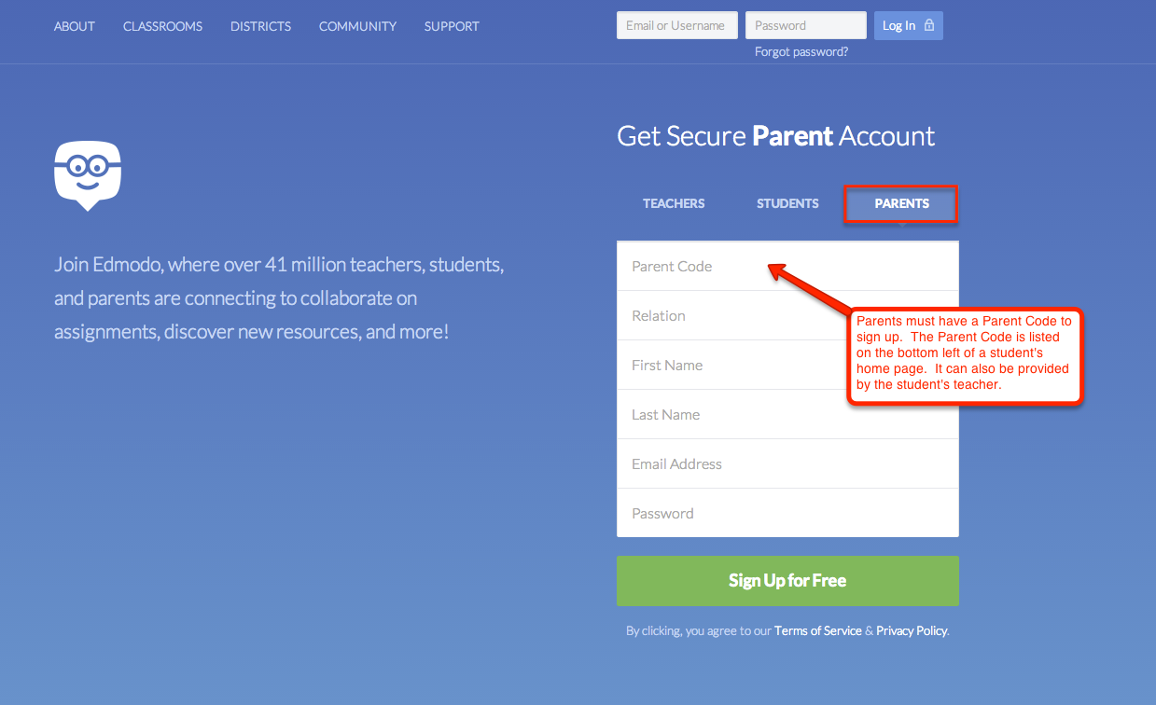

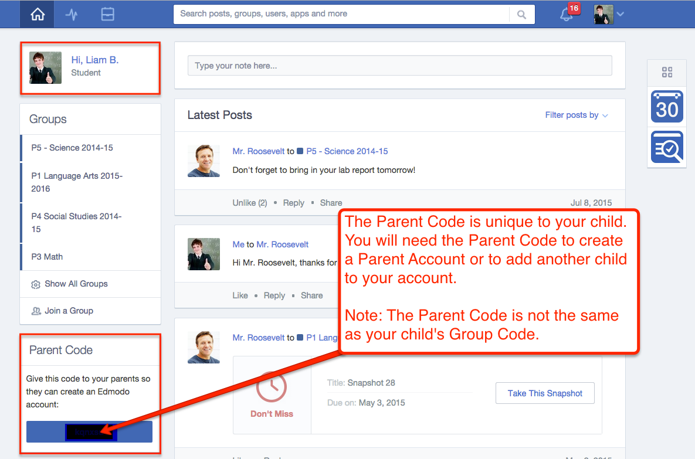

Best Practices for Using Parent Accounts (Parent)
Whether it's having students use an avatar as a Profile picture or making a habit of logging out after using Edmodo, we've compiled a few best practices:
Set Expectations with Your Child
- Although your child’s school will have its own expectations and guidelines for using the internet and Edmodo Accounts, it is important for you to discuss and set your own guidelines with your children regarding Internet usage.
- We encourage you to review your child’s school’s Internet usage policy and discuss it with your child, the teacher, and the school.
Use a Secure Password When Creating an Account
- Students should create unique student passwords. Using generic passwords (such as “password”, “Name”123, or birthdates) makes it easy for students to guess each other’s passwords. Passwords are case sensitive.
Setting up Email or Text Notifications
- Notifications alert you to new activity in your child’s account. We recommend setting up email or text notifications to help you monitor your child’s posts and progress in school. To turn on these notifications, visit your Account Settings page. You will also automatically be notified on your Homepage about activity on your child's account.
Replying to Posts from Your Child's Teachers
With the Edmodo for Parents apps on iOS or Android, you can now reply to some posts. You can only reply if the Post is sent to Parents only (i.e. no Students are receiving the Post, too), and are using the Edmodo for Parents app. Keep in mind, your reply will be visible to all of the Parents who received the Post. Think of it as a Reply-All in email.

If you have any questions or concerns, please contact me at school or send me an email at the following address: stacey.strenge@k12.nd.us. I am more than willing to help you set up an account.

