Reading Rhetorically
Part 1

Directions: With you group, you will explore three different webpages and
answer the following questions for each site:
- What is its purpose?
- Who is the target audience?
- In what genre is it written?

Website 1: Lumosity –
http://www.lumosity.com
*Click on The Science tab and then click on Key Concepts
- What is its purpose?
- Who is the target audience?
- In what genre is it written?

Website 2: Your Brain & Nervous System -
http://kidshealth.org/kid/htbw/brain.html
- What is its purpose?
- Who is the target audience?
- In what genre is it written?

Website 3: Emily Dickinson’s “The brain is wider than the sky”
http://www.bartleby.com/113/1126.html
- What is its purpose?
- Who is the target audience?
- In what genre is it written?

Once you have completed the above activity, post your answer on Edmodo to the following question: In each case, how have the author’s purpose, the intended audience, and the genre influenced the way you understood the different websites?
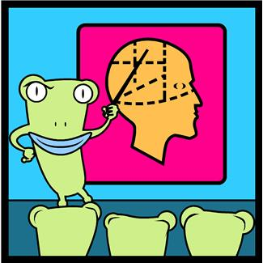

Reading Rhetorically
Part 2

Directions: In the last activity, you examined three different websites that had a common topic – the brain. However, they were designed for different purposes. Now I want you to design a similar activity to demonstrate your understanding of reading rhetorically. You will create an activity similar to the one you just completed with one exception; you will provide the answers to the questions you ask. Be sure you save your work on the server. This is a group activity so each member needs to contribute to complete this project. You will be grading yourself and each other.

Note:
- Once your group has decided on a common topic, you need to let me know so another group cannot repeat it.
- The topic of the brain has already been used.
- Be creative and do some thorough research before you pick a topic.
- Make sure your topic and assignment are school appropriate.
- If you don’t understand something, please ask for assistance.
