SpeakPipe

- Be sure to listen to how each word of the lesson is pronounced using Dictionary.com.
- Practice saying the words and annunciating correctly.
- You will not be able to pause when you record your lesson so you will have to say all of your words from start to finish in one setting.
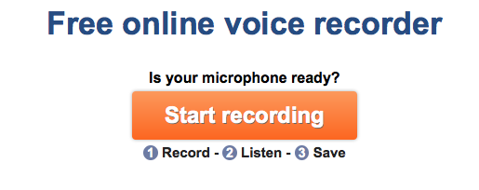
- Go to Wyndmere’s Homepage.
- Go under Faculty and Staff.
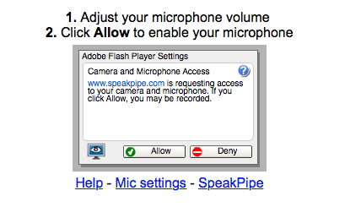
- Click on SpeakPipe.
- Click on Start Recording.
- Click on Allow.
- It will start recording (Speak Now). When you are finished, click on Stop.

- If it says your recording is too quiet, you need to redo your recording.

- ALWAYS Replay to hear your lesson. If your words aren’t clearly annunciated, you must redo your recording. I can’t give you credit for words that are missing or mispronounced.

- Click Save on Server.
- Save Recording on Server: Be sure to save this using the following format: First and Last Name Unit ___.
- Click on Save.
- Click on Link to this Recording.
- Click on Download.
- Your lesson will be located in the download file.
- Listen to it carefully to make sure you have all of the required terms and they are pronounced correctly.

- Find your file and rename it: First and Last Name Unit **
First and Last Name Unit **

Example:
StaceyStrengeUnit1

- Open your Shared Docs.

- “Grab” your Unit file and then drag it Mrs. Strenge’s Submit folder.

- If you do this correctly, a message will pop up that says you won’t be able to see the assignment once you submit. Be sure to click on submit. In order to earn credit, your assignment must be in the SUBMIT folder before class begins (the bell rings) on Mondays.

- If you aren’t sure that your assignment has been submitted correctly, please see me before class begins. If it is not there, you need to plan enough time so that you may resubmit your assignment before class begins so that it is not counted as late. Please plan accordingly. Most students submit their lesson on Friday.

- Please see me if you have any questions.

