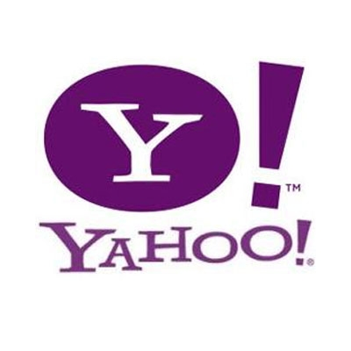
WEBSITES
Are they credible?

Tip 1: Check the URL.
*The domain name gov is restricted to government entities. This domain has
extremely restricted guidelines.
Ex: .gov – http://www.kids.gov

*The domain name edu is intended for accredited educational institutions. This
also has restricted guidelines.
Ex: .edu – http://owl.english.purdue.edu

*The domain name com is used to designate commercial entities and there are
basically no restrictions as to whom can register .com domains.
Ex: .com – http://www.youtube.com

*The domain name org classifies organizations ranging from nonprofit to political and trade associations. There are no restrictions as far as to whom can use the .org suffix.
Ex: .org – http://www.stjude.org / http://www.craigslist.org

*The domain name net stands for “network,” and this is used by Web hosting companies, Internet service providers, and other businesses. There are no restrictions as far as to whom can use the .net suffix.
Ex: .net – http://teachers.net

Tip 2: Authorship
*A credible website will provide the names of the authors and the information about them. Sometimes the search for the author takes some detective work, and a good place to start would be the home page. In certain instances, an organization will be the author.
*Questions to Ask:
Is the name of the author present?
Is there a way to contact the author?
Are the author’s credentials listed?
Are there any clues that the author is biased?

Tip 3: Purpose
*A credible website will be upfront and honest about its purpose.
*Questions to Ask:
What is the site trying to do? What is its purpose?
Why was the site created?
Was the site created to sell a product or promote a particular idea?
Was the site created solely for the purpose of entertainment?
Is the site bias?
Have you investigated this site thoroughly?

Tip 4: The Tilde~
*Look closely at a website’s URL. If it contains a tilde (~), it means that this portion of the site is created, published, and maintained by someone else. Universities typically allow their students to create webpages, but that doesn’t necessarily mean the schools endorse the material.
*Questions to Ask:
Is there a tilde in the URL address?

Tip 5: The Date
*In order to cite a source, there has to be a date and it should be relatively current.
Check to see when the site was created and when it was last updated.
*Questions to Ask:
Has the site been updated recently?
Does it contain current information?
Does the site contain a copyright date?

Tip 6: The Design
*Look to see if the design of the webpage and its links are professional and formal.
A credible website won’t contain misspelled words, grammatical mistakes, or profanity. It’s possible there may be some advertisements present, but if they are flashy, inappropriate, and/or constantly interrupt, you should investigate the credibility of the website.
*Questions to Ask:
Does the site have errors?
Is the information easy to find and easy to read?
Is the material/graphics appropriate?

Tip 7: When in Doubt…
*If you are not sure whether a website is credible or not, skip it. There are
millions of Websites on the Internet; use only the ones you can PROVE are
credible.

