What to do when you finish your writing assignment...
- Check for Spelling, Grammar, and Other Tools.
- Copy & Paste your assignment onto a WORD Document (not Google Docs).
- Take care of any mistakes that show up (green or red lines)
- Use Paper Rater to get helpful hints.
- Delete Captain Obvious sentences -
  - This article is about… In this paragraph…
- Check for Readability – it MUST BE AT GRADE LEVEL.
- Use COMMAND F and see if you are using state-of-being verbs (is, am, was, were, be, etc.). These are not high level verbs. Restructure your sentences and use action verbs.
- Use COMMAND F to find point of view (I, me, we, us, you, etc.).
- Use COMMAND F to find main words (key words that were in the vocabulary challenge - greenhouses, heat, etc.
- Show - Don’t Tell! Create an image/picture in your reader’s mind.
  - For example:
    - He is happy. (Grade Level: 0)
    - He smiled when he went outside. (Grade Level: 3)
    - As he was met with an arctic blast of fresh air, a genuine smile spread across his face and set the mood for the rest of his day. (Grade Level: 7)
- Go through your NOTES for what to include in a particular writing piece and make sure you have ALL THE REQUIREMENTS (summary, persuasive, narrative, etc.).
- Read over it one more time aloud (quietly) and then LISTEN to it using the Text Speaker (my website).
- Copy and paste your changes back into the TEXTBOX and SAVE.
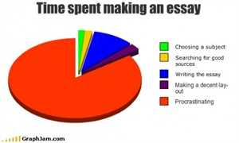
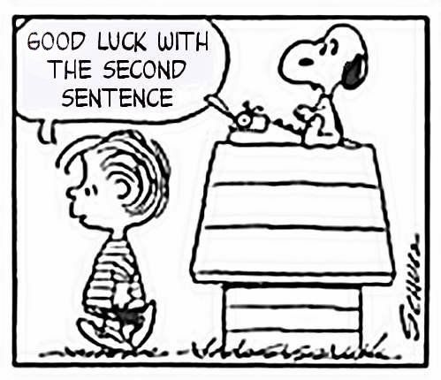
- Click GET FEEDBACK.

